TESTING EXERCISE REPORT

CONTENT

**Partial Test Plan** **2**

Overview 2

Test plan 2

Test cases 3

Test execution protocol 10

Test execution summary and chart 13

**Exploratory Testing Log & Report** **14**

Session 1 14

Session 2 16

Session 3 18

Session 4 21

Statistics from exploratory sessions 23

**Issues Found and Reported** **24**

# 

# Partial Test Plan

## **Overview**

The Beaulieu Vineyard has an e-commerce website <https://www.bvwines.com/> that allows the visitors of their page to buy wine. The platform gives the opportunity to both registered and not registered users to make a purchase. The wine is delivered and not picked up, therefore the user must enter the delivery address, which may differ from the billing address. There are states to which some items cannot be delivered. The platform offers other options like joining membership clubs and having virtual and on-site tours, or reading more about the company and contacting them.

## **Test plan**

|  |  |
| --- | --- |
| **Scenario Name** | Browse items and make a purchase as a guest |
| **Test objective** | The test will be performed to verify the functionality of website bvwines.com. The project should focus on testing browse items and checkout as guest functionality which includes: browsing through all items, checking the details of items, adding items to shopping cart, manipulating the quantities and items in the shopping cart, checkout as guest. It ends when the user reaches the payment options page. |
| **Scope** | * Page with items (All wines) - as guest user can see all the items * Detailed view of an item - as guest user can see the details of an item * Shopping cart - as guest user can add and manipulate different quantities of different items * Checkout - as guest user can add address information and delivery option and move to payment |
| **Out of scope** | * Other than All wines and checkout pages * Filter items * Make a registration * Use the site and buy items as a registered or returning user * Website security and performance |
| **Entry criteria** | The tester has a desktop PC with running OS Windows 10 and Google Chrome v.91.0.4472.114 in incognito mode opened on All wines [bvwines.com/en/wines/all-wines](http://www.bvwines.com/en/wines/all-wines) |
| **Exit criteria** | Specifies the criteria that denote a successful completion of a test phase   * Run rate is 100% unless a clear reason is given. * Pass rate is 92%. Achieving the pass rate is mandatory |
| **Tests to be performed** | * Functional Testing |
| **Tests which must not be performed** | * Performance testing * Load testing * Stress testing * Security testing |
| **Test cases** | PG001, PG002, PG003, PG004, PG005  Positive scenario achieved with: PG001, PG003 |

## **Test cases**

|  |  |  |  |
| --- | --- | --- | --- |
| **Test case PG001** | | | |
| **Name** | Browse through the items and add items to the shopping cart | | |
| **Objective** | Confirm that the user is able to see the listed items, their properties and order forms. Available items can be added to the shopping cart with the correct price and quantities. | | |
| **Precondition** | The website is open in English on All wines ( [www.bvwines.com/en/wines/all-wines](http://www.bvwines.com/en/wines/all-wines) ) in the browser in incognito mode The user marked “No thanks” on the join the mailing list pop-up. No other actions were performed before the test.There are more than 12 items for sale, each in its own box. The item box contains at least: Name, Winery, Price in $ and picture of a bottle. An additional info might exist on some items from the left or the right side of the bottleneck. | | |
| **Step** | **User actions** | **Expected result** | **Pass | Defect #** |
| 1 | Scroll to the end of the item list | There is a button "LOAD MORE" after the last row of items. | |  |  | | --- | --- | | Pass |  | |
| 2 | Click on "LOAD MORE" and scroll down. (do this twice) | All products are shown. “LOAD MORE” is gone from the page. | |  |  | | --- | --- | | Pass |  | |
| 3 | Look for item "2016 Ranch No. 1 Maestro Red Wine" by scrolling up or down and hover over it with the cursor on item’s the name | Тhe bottle picture is replaced by:   * Short description * Order form containing:  1. 2 tabs - Bottle, Case (12) 2. Qty, Single price, Your price 3. Editable field, $n.00, 2 links 4. Button "ADD TO CART"  * Link "DETAILS"   The pointer of the cursor is changed from “default” to “pointer”. | |  |  | | --- | --- | | Pass |  | |
| 4 | Change Qty from 1 to 3 and click next to the field (out of it) | The input field is with value 3. | |  |  | | --- | --- | | Pass |  | |
| 5 | Click on "ADD TO CART" button | A pop-up window to choose the state from a dropdown. | |  |  | | --- | --- | | Pass |  | |
| 6 | Choose "Oregon" from the dropdown and click "Confirm" | Ship To on the top changes to OR.  Indicator on the shopping cart icon showing 3 appears.Order summary pops out with "Cart Subtotal $285.00''. The order is editable. | |  |  | | --- | --- | | Pass |  | |
| 7 | Look through All wines, locate "2016 Maestro Port 500ml" and click on "DETAILS" | A new page with items' detailed info opens in the same tab. | |  |  | | --- | --- | | Pass |  | |
| 8 | Browse through all the pictures of the item by clicking on the arrows left or right of the large picture or by clicking between the small pictures under it | The large picture changes correctly and shows the expected image. All pictures are fully visible. | |  |  | | --- | --- | | Pass |  | |
| 9 | Choose tab "Case (12)" from the order form | Retail price changes to "$600.00". | |  |  | | --- | --- | | Pass |  | |
| 10 | Change Qty from 1 to 2 and click outside the field | Qty is 2. | |  |  | | --- | --- | | Pass |  | |
| 11 | Click on "ADD TO CART" button | Shopping cart is focused and the identificator is 5.  "Cart Subtotal" is "$1,485.00". 2 records are in. | |  |  | | --- | --- | | Pass |  | |
| 12 | Go back to All wines by using the browser's back button | The page returns to the same position that it was when the item was open. | |  |  | | --- | --- | | Pass |  | |
| 13 | Hover over item "2015 Beaulieu Vineyard Clone 6 Cabernet Sauvignon" and click the name of the item | The order form is replaced by "OUT OF STOCK" on hover over the item and in the details page, which opens. | |  |  | | --- | --- | | Pass |  | |
| 14 | Go back to the Wine menu with All wines by using the browser's button for back and hover over the shopping cart | There is a shopping summary with containing:   * "Cart Subtotal" of "$1,485.00" * button "CHECKOUT" * 2 editable item records,  1. "Qty 3", "Single $95.00" 2. "Qty 2", "Case (12) $600.00"  * "UPDATE" button on the right side of "Qty” * price for "Item total" | |  |  | | --- | --- | | Pass |  | |
| **Designed by** | Georgi Angelov | **Designed on** | 24.06.2021, 13:38 |
| **Execution** | | | |
| **Tested by** | Georgi Angelov | **Test started on** | 27.06.2021, 15:20 |

# 

|  |  |  |  |
| --- | --- | --- | --- |
| **Test case PG002** | | | |
| **Name** | Shopping Cart manipulation | | |
| **Objective** | The user should be able to successfully add and remove products from the shopping cart. | | |
| **Precondition** | Тhe web site is open on page with products list and shipment state is selected. | | |
| **Step** | **User actions** | **Expected result** | **Pass | Defect #** |
| 1 | Add 10 bottles of "2016 Ranch No. 1 Maestro Rutherford Red Wine" using the "ADD TO CART" button. | Shopping cart should contain Qty 10 of selected products. The counter of the shopping cart icon should be 10. The "Item total" should be 10* Single price and cart Subtotal should be the same as Item total. | |  |  | | --- | --- | | Pass |  | |
| 2 | Add 10 bottles of "2016 Ranch No. 1 Maestro Rutherford Red Wine" using the "ADD TO CART" button. | Shopping cart should not contain duplicates of the selected product, the Qty of the product should be 20. The counter of the shopping cart icon should be 20. The "Item total" should be 20* Single price and Cart Subtotal should be the same as Item total. | |  |  | | --- | --- | | Pass |  | |
| 3 | Change QTY to 10 of "2016 Ranch No. 1 Maestro Rutherford Red Wine" using the "UPDATE" button on Shopping cart. | The QTY in the shopping cart of the selected product should be 10. The counter of the shopping cart icon should be 10.The value of "Item total" and "Cart Subtotal" should be 10* Single price. | |  |  | | --- | --- | | Pass |  | |
| 4 | Add 10 bottles of "2018 Maestro Reserve Napa Valley Chardonnay" using the "ADD TO CART" button. | Shopping cart should contain two products, each with Qty 10. The counter of the shopping cart icon should be 20. The "Item total" for each product should be 10* Single price and Cart Subtotal should be the sum of Items total. | |  |  | | --- | --- | | Pass |  | |
| 5 | Add one of the suggest wines in Shopping Cart section "You May Also Like " with "ADD TO CART" button | The new wine should be added to the shopping cart with Qty 1. The counter of the shopping cart icon should be 21. The "Item total" for each product should be Qty* Single price and Cart Subtotal should be the sum of Items total. | |  |  | | --- | --- | | Pass |  | |
| 6 | Remove "2016 Ranch No. 1 Maestro Rutherford Red Wine" from Shopping Cart. | A dialog box for removal confirmation is displayed. | |  |  | | --- | --- | | Pass |  | |
| 7 | Choose the "Remove " button on the dialog box. | Shopping cart does not contain "2016 Ranch No. 1 Maestro Rutherford Red Wine". The counter of the shopping cart and Cart Subtotal is updated. | |  |  | | --- | --- | | Pass |  | |
| 8 | Click on "CHECKOUT" button | "Checkout" page is displayed. | |  |  | | --- | --- | | Pass |  | |
| 9 | Click on "Checkout as guest" button | Delivery Address form is loaded. | |  |  | | --- | --- | | Pass |  | |
| **Designed by** | Georgi Angelov | **Designed on** | 24.06.2021, 19:45 |
| **Execution** | | | |
| **Tested by** | Georgi Angelov | **Test started on** | 27.06.2021, 15:31 |

# 

# 

|  |  |  |  |
| --- | --- | --- | --- |
| **Test case PG003** | | | |
| **Name** | The user completes the check out with same billing and delivery address - positive | | |
| **Objective** | The user should be able to successfully complete the purchase with valid input data and same billing and delivery address | | |
| **Precondition** | The PG003 case is a continuation of PG001.  The products and quantities selected in Test case PG001 are in the shopping cart. The button "Checkout" is clicked from the top of the shopping cart and the option "Checkout as guest" is chosen. | | |
| **Step** | **User actions** | **Expected result** | **Pass | Defect #** |
| 1 | Check the order summary | The order summary shows:  3 Single bottles  2 Case (12)  Subtotal: $1485.00  No promo codes added.  All quantities are editable. | |  |  | | --- | --- | | Pass |  | |
| 2 | Еnter valid data into the shipping form input fields:  email address: test@test.test  first name: John  surname: Smith  street address: 4655 Satter dr NE  city: Salem  state: Oregon  zip code: 97305  DD/MM/YYYY: 04/18/1988 | All input data is accepted | |  |  | | --- | --- | | Pass |  | |
| 3 | Billing address same as delivery address "YES" is preselected | The slide button is in red | |  |  | | --- | --- | | Pass |  | |
| 4 | List of shipping methods is displayed | Yes | |  |  | | --- | --- | | Pass |  | |
| 5 | The user selects one of the listed options (UPS Ground) | The delivery costs are added to subtotal | |  |  | | --- | --- | | Pass |  | |
| 6 | The user clicks on "proceed to payment" button | The user is directed to payment page | |  |  | | --- | --- | | Pass |  | |
| **Designed by** | Georgi Angelov | **Designed on** | 24.06.2021 |
| **Execution** | | | |
| **Tested by** | Georgi Angelov | **Test started on** | 27.06.2021, 15:57 |

|  |  |  |  |
| --- | --- | --- | --- |
| **Test case PG004** | | | |
| **Name** | The user completes the check out, different billing and delivery address - positive | | |
| **Objective** | The user should be able to successfully complete the purchase with valid input data and different billing and delivery address | | |
| **Precondition** | The user has already selected a product in the shopping cart and clicked "checkout as guest" button | | |
| **Step** | **User actions** | **Expected result** | **Pass | Defect #** |
| 1 | The user enters valid data into the shipping form input fields: email address: test@test.test ; first name: John ; surname: Smith ; street address: 4655 Satter dr NE ; city: Salem ; state: Oregon ; zip code: 97305 ; DD/MM/YYYY as fallow 04/18/1988 | All input data is accepted | |  |  | | --- | --- | | Pass |  | |
| 2 | The user selects "NO" with the slide bar for "Billing address same as delivery" | The slide button is in grey | |  |  | | --- | --- | | Pass |  | |
| 3 | The user inputs valid data into billing address form: email address: test1@test.test ; first name: John : surname: Smith ; street address: 3640 Wade St ; country: United States ; state : California ; city: Los Angeles ; zip code: 90066 ; MM/DD/YYYY as fallow 11/21/1984 | All input data is accepted | |  |  | | --- | --- | | Pass |  | |
| 4 | List of shipping methods is displayed | Yes | |  |  | | --- | --- | | Pass |  | |
| 5 | The user selects one of the listed options (UPS Ground) | The delivery costs are added to subtotal | |  |  | | --- | --- | | Pass |  | |
| 6 | The user clicks on "proceed to payment" button | The user is directed to a payment page | |  |  | | --- | --- | | Pass |  | |
| **Designed by** | Georgi Angelov | **Designed on** | 24.06.2021 |
| **Execution** | | | |
| **Tested by** | Georgi Angelov | **Test started on** | 27.06.2021, 16:08 |

|  |  |  |  |
| --- | --- | --- | --- |
| **Test case PG005** | | | |
| **Name** | The user inputs invalid data for delivery and billing address form - negative | | |
| **Objective** | The user shouldn't be able to successfully complete the purchase with invalid input data for delivery and billing address | | |
| **Precondition** | The user has already selected a product in the shopping cart and clicked "checkout as guest" button | | |
| **Step** | **User actions** | **Expected result** | **Pass | Defect #** |
| 1 | The user enters invalid data for email address: t@t.t | "Error: Please enter a valid E-Mail address" message is displayed | |  |  | | --- | --- | | Pass |  | |
| 2 | The user enters invalid data for first name: “Джон” | "Error: Please match the requested format." message is displayed | |  |  | | --- | --- | | Pass |  | |
| 3 | The user enters invalid data for surname name: 1 | "Error: Please match the requested format." message is displayed | |  |  | | --- | --- | | Pass |  | |
| 4 | The user leaves street address input field empty | "Error: This field is required." message is displayed | |  |  | | --- | --- | | Pass |  | |
| 5 | The user enters invalid data for city: A | "Error: Must be between 2 to 50 characters required." message is displayed | |  |  | | --- | --- | | Fail | 05 | |
| 6 | The user enters invalid data for zip code: 1234 | "Error: Must be between 5 to 10 characters required." is displayed | |  |  | | --- | --- | | Fail | 06 | |
| 7 | The user enters invalid data for company name: more than 50 characters | "Error: Must be less than 50 characters required." message is displayed | |  |  | | --- | --- | | Fail | 07 | |
| 8 | The user enters invalid data for contact phone: 22 | "Error: Please enter a valid phone number" message is displayed | |  |  | | --- | --- | | Pass |  | |
| 9 | The user enters valid dаta but as of the date of the test the user should be less than 21 years of age | "Error: You must be at least 21 years of age" message is displayed | |  |  | | --- | --- | | Pass |  | |
| **Designed by** | Georgi Angelov | **Designed on** | 24.06.2021 |
| **Execution** | | | |
| **Tested by** | Georgi Angelov | **Test started on** | 27.06.2021, 16:16 |

## **Test execution protocol**

|  |  |  |  |  |  |  |  |
| --- | --- | --- | --- | --- | --- | --- | --- |
| Step | Test case  step description | Expected result | Bug ID | Description | Test started | Test ended | Test executed by |
| **Browse through the items and add items to the shopping cart** | |  |  | PG001 | 27.06.2021, 15:20 | 27.06.2021, 15:30 | Georgi Angelov |
|  | **Initial steps** |  |  |  |  |  |  |
| 1 | Scroll to the end of the item list | PASS |  |  |  |  |  |
| 2 | Check the "LOAD MORE" button's function | PASS |  |  |  |  |  |
| 3 | Item's order form appears on hover over the item | PASS |  |  |  |  |  |
| 4 | Enter quantity 3 for Single bottle | PASS |  |  |  |  |  |
| 5 | Add to basket from quick order form | PASS |  |  |  |  |  |
| 6 | Choose a valid state for delivery | PASS |  |  |  |  |  |
| 7 | Check the full details for a product | PASS |  |  |  |  |  |
| 8 | Check the pictures of a product | PASS |  |  |  |  |  |
| 9 | Choose tab "Case (12)" from the order form | PASS |  |  |  |  |  |
| 10 | Change quantity 2 for Case (12) | PASS |  |  |  |  |  |
| 11 | Add the 2 cases to the shopping cart | PASS |  |  |  |  |  |
| 12 | Go back to the previous page with all the items | PASS |  |  |  |  |  |
| 13 | Check for an Out of stock item and click its details | PASS |  |  |  |  |  |
| 14 | Go back to the previous page with all the items and review the shopping cart | PASS |  |  |  |  |  |
| **Shopping Cart manipulation** | |  |  | PG002 | 27.06.2021, 15:31 | 27.06.2021, 15:41 | Georgi Angelov |
|  | **Initial steps** |  |  |  |  |  |  |
| 1 | Add 10 bottles of "2016 Ranch No. 1 Maestro Rutherford Red Wine" using the "ADD TO CART" button. | PASS |  |  |  |  |  |
| 2 | Add 10 bottles of "2016 Ranch No. 1 Maestro Rutherford Red Wine" using the "ADD TO CART" button. | PASS |  |  |  |  |  |
| 3 | Change QTY to 10 of "2016 Ranch No. 1 Maestro Rutherford Red Wine" using the "UPDATE" button on Shopping cart. | PASS |  |  |  |  |  |
| 4 | Add 10 bottles of "2018 Maestro Reserve Napa Valley Chardonnay" using the "ADD TO CART" button. | PASS |  |  |  |  |  |
| 5 | Add one of the suggest wines in Shopping Cart section "You May Also Like " with "ADD TO CART" button | PASS |  |  |  |  |  |
| 6 | Remove "2016 Ranch No. 1 Maestro Rutherford Red Wine" from Shopping Cart. | PASS |  |  |  |  |  |
| 7 | Choose the "Remove " button on the dialog box. | PASS |  |  |  |  |  |
| 8 | Click on "CHECKOUT" button | PASS |  |  |  |  |  |
| 9 | Click on "Checkout as guest" button | PASS |  |  |  |  |  |
| **The user completes the check out with same billing and delivery address - positive** | |  |  | PG003 | 27.06.2021, 15:57 | 27.06.2021, 16:07 | Georgi Angelov |
|  | I**nitial steps** |  |  |  |  |  |  |
| 1 | Order summary shows the added items without change | PASS |  |  |  |  |  |
| 2 | The user enters valid data into the shipping form input fields. | PASS |  |  |  |  |  |
| 3 | Billing address same as delivery address "YES" is preselected | PASS |  |  |  |  |  |
| 4 | List of shipping methods is displayed. | PASS |  |  |  |  |  |
| 5 | The user selects one of the listed options. | PASS |  |  |  |  |  |
| 6 | The user clicks on "proceed to payment" button. | PASS |  |  |  |  |  |
| **The user completes the check out, different billing and delivery address - positive** | |  |  | PG004 | 27.06.2021, 16:08 | 27.06.2021, 16:15 | Georgi Angelov |
|  | **Initial steps** |  |  |  |  |  |  |
| 1 | The user enters valid data into the shipping form input fields. | PASS |  |  |  |  |  |
| 2 | The user selects "NO" with the slide bar for "Billing address same as delivery" | PASS |  |  |  |  |  |
| 3 | The user inputs valid data into billing address form. | PASS |  |  |  |  |  |
| 4 | List of shipping methods is displayed. | PASS |  |  |  |  |  |
| 5 | The user selects one of the listed options. | PASS |  |  |  |  |  |
| 6 | The user clicks on "proceed to payment". | PASS |  |  |  |  |  |
| **The user inputs invalid data for delivery and billing address form - negative** | |  |  | PG005 | 27.06.2021, 16:16 | 27.06.2021, 16:34 | Georgi Angelov |
|  | I**nitial steps** |  |  |  |  |  |  |
| 1 | The user enters invalid data for email address: t@t.t | PASS |  |  |  |  |  |
| 2 | The user enters invalid data for first name:”Джон” | PASS |  |  |  |  |  |
| 3 | The user enters invalid data for surname name: 1 | PASS |  |  |  |  |  |
| 4 | The user leaves street address input field empty | PASS |  |  |  |  |  |
| 5 | The user enters invalid data for city: A | FAIL | 05 | The error message is “Error: Must be less than 50 characters required.” |  |  |  |
| 6 | The user enters invalid data for zip code: 1234 | FAIL | 06 | The field does not accept strings with length different than 5 digits. |  |  |  |
| 7 | The user enters invalid data for company name: more than 50 characters | FAIL | 07 | There is no error message. |  |  |  |
| 8 | The user enters invalid data for contact phone: 22 | PASS |  |  |  |  |  |
| 9 | The user enters valid dаta but as of the date of the test the user should be less than 21 years of age | PASS |  |  |  |  |  |

## **Test execution summary and chart**

|  |  |  |  |  |  |  |  |  |  |  |  |  |  |  |  |  |  |  |  |  |  |  |  |  |
| --- | --- | --- | --- | --- | --- | --- | --- | --- | --- | --- | --- | --- | --- | --- | --- | --- | --- | --- | --- | --- | --- | --- | --- | --- |
| |  |  |  | | --- | --- | --- | | **Total Steps in Cases** | **44** | **100.00%** | | PASS | 41 | 93.18% | | FAIL | 3 | 6.82% | | BLOCKED | 0 | 0.00% | | KNOWN ISSUE | 0 | 0.00% | | SKIPPED | 0 | 0.00% | | TO DO | 0 | 0.00% | | **Total Steps Ran:** | **44** | **100.00%** |   Chart |

# Exploratory Testing Log & Report

## **Session 1**

* Charter: Contact us form
* Areas: Required fields
* Test Environment URL: <https://www.bvwines.com/>
* Test Username:
* Start: 21 June 2021 – 13:46
* Testers: Georgi Angelov
* Duration: 30 min
* End: 13:58

**Testing Notes:**

13:46 - Open <https://www.bvwines.com/>.

13:46 - Click on “Contact Us” from the footer.

13:46 - Successfully redirected to “Contact Us” page.

13:47 - When we click on “Submit” button without any entered info and verified reCAPTCHA, an error message appears that fields are mandatory.

13:48 - The message field has to be required like the others.

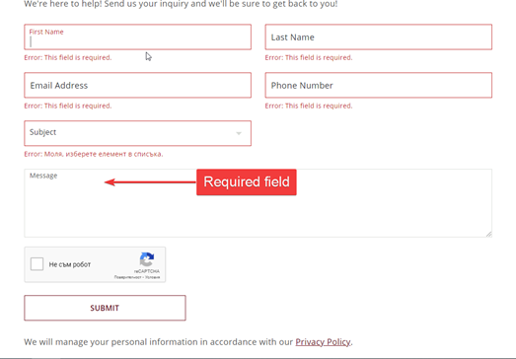

13:50 - Successfully error message: “Please take reCaptcha challenge.”, when you try to avoid the reCAPTCHA security with valid info in all required fields.

13:51 - The reCAPTCHA requires re-verification if we delay sending the message.

13:55 - The fall down menu for "Subject" works as expected.

13:56 - Successfully reject of invalid symbols in the required fields.

13:58 - Enter correct information in all required fields, verify the reCAPTCHA, stay on first name, last name, email or phone number field and press Enter. The contact message was sent.

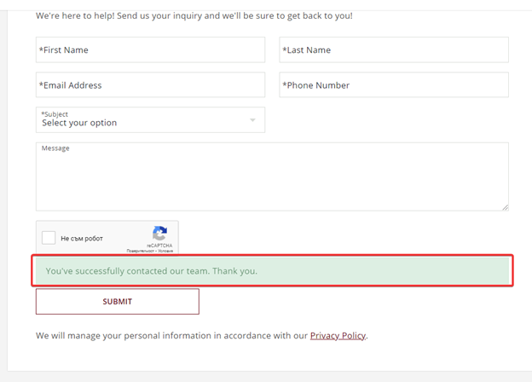

13:58 - Session ends.

## **Session 2**

* Charter: Login form
* Areas: Forgotten password
* Test Environment URL: <https://www.bvwines.com/>
* Test Environment: Version 91.0.4472.114 (Official Build) (64-bit), Windows 10 Pro 10.0.19041 Build 19041
* Test Username:
* Start: 22 June 2021 – 16:25
* Testers: Georgi Angelov
* Duration: 30 min
* End: 16:55

**Testing Notes:**

16:25 - Open <https://www.bvwines.com/>.

16:26 - Click on “Log in” from the footer.

16:27 - Successfully redirected to the “Log in” page.

16:28 - Shows accurately the login form.

16:29 - Successfully log in with valid credentials.

16:30 - Log out from the “account icon” from the header menu.  
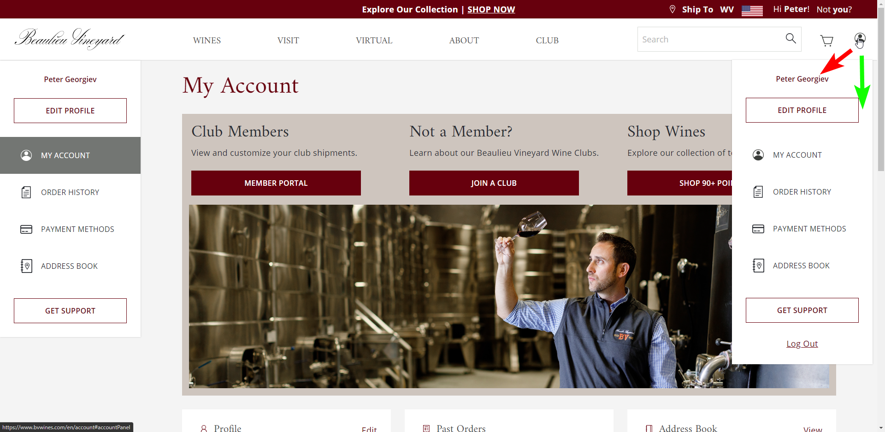

16:35 - Login form is unusable after one correct use of the forgotten password option and after clicking on the option again.

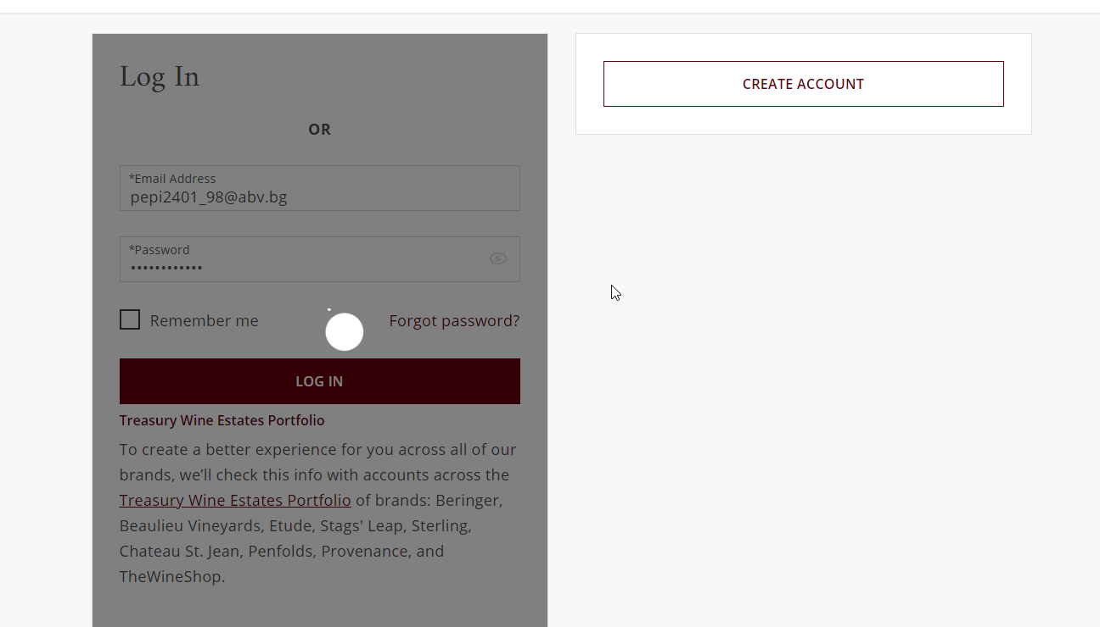  
16:45 - Invalid log in with bad credentials. Incorrect message: "Invalid login or password" should be "Invalid email or password".

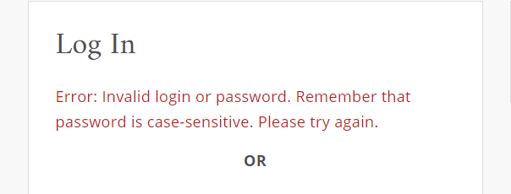

16:55 - The button “Not you?” is equal to Log out, there is no suggestion or additional information about if there is another option different from not you.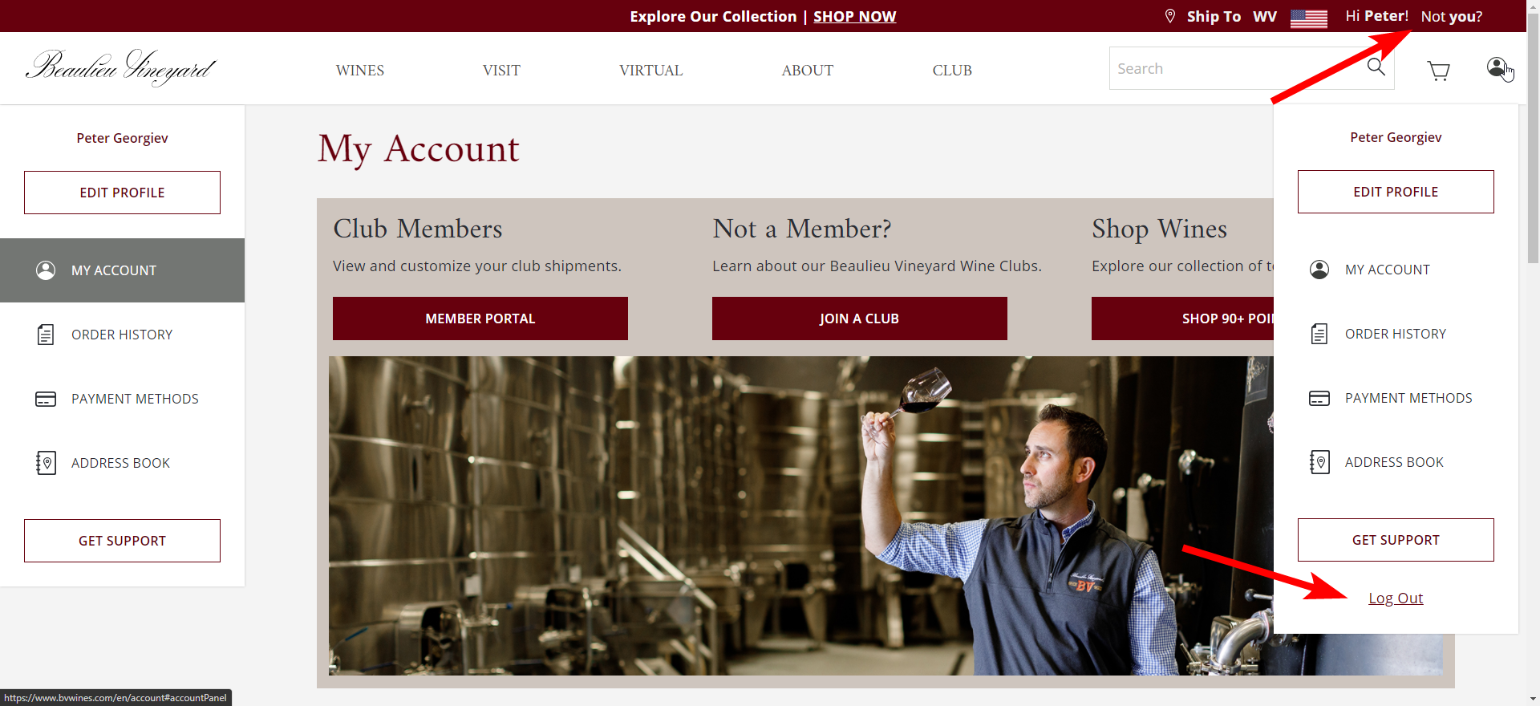

16:55 - Session ends.

## **Session 3**

* Charter: User registration and account settings
* Areas: Create account and Edit profile
* Test Environment: Chrome 91.0.4472.106; Windows 10 Pro 19043.1052
* Test Username: John
* Start: 22. June.2021 – 18:42
* Testers: Georgi Angelov
* Duration: 60 min
* End: 22. June. 2021 - 19:35
* Tour based testing: The landmark tour

**Testing Notes:**

18:42 Open new browser window to address: <https://www.bvwines.com/>

18:43 Click on “Log In” in the upper right corner.

Observation: there is “OR” text in the middle of the Log In white box.

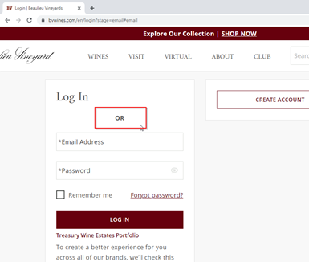

18:45 Click on “Create account”

18:46 Click on “First Name” field. Enter text “John”

18:47 Click on “Last Name” field. Enter text “Smith”

18:48 Click on “MM” field. Click on “DD” field.

Observation: The required fields are marked with * before the placeholder as the initial state. After entering and exiting a textfield, the placeholder text no longer begins with *. This can be confusing behavior for the user.

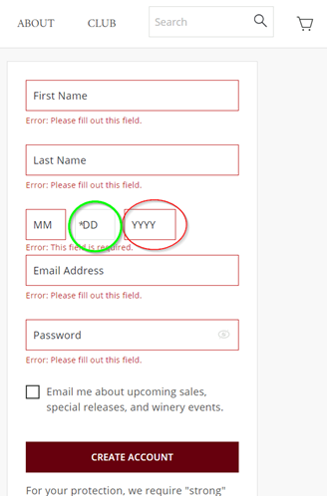

18:55 Click on the “MM” field and try to enter the date June 1st as 1.6.  
Wrong hint text is displayed: “Error: Please enter a valid value. The two nearest”. Hint changes to “Error: This field is required.” on leaving the focus.  
19:00 Entering date February 29, 1988 is accepted by the system, as it is a leap year.   
19:05 Entering February 29, 1977 is not accepted by the system, which is fine.  
19:09 Entering valid email in Email address field  
19:11 Typing “zzzzzzzz” as a password and clicking on “Create account”, returns an error with directions to the instructions for password criteria.  
19:12 Typing “Pa!1rola” and clicking “Create account” navigates me to “Welcome” page.  
Observation: There is a gray rectangle in the bottom right corner.

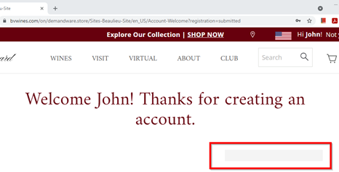

19:14 Click on the user profile icon in the upper right corner, and select “Edit profile” from the drop down menu.  
19:15 Click on the “Primary Phone Number” field and type in 111111111111111111. The form displays an error hint “Error: Please enter a valid phone number”.  
19:17 Delete digits with Backspace, and enter “1234567890”. The error message is removed.  
19:19 Click on the “First Name” field under the “Secondary Household Member” section. Type “Angelina”.  
19:20 Click on the next “Last Name” field. Type “A-12”. An error hint is shown “Error: Please match the requested format”.  
Observation: the error hint does not explain the format required. It should say Latin letters only.

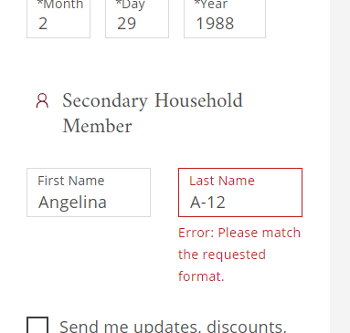

19:25 Correct Last Name to text “Aa”. Error hint is removed.  
19:29 Click on button “Save”. Site navigates to the account page (<https://www.bvwines.com/en/account>)  
19:35 End of session.

## **Session 4**

* Charter: Testing of “Filter”, “Sort by” functions and “ADD TO CART”
* Areas: “View All Wines” Page
* Test Environment URL: <https://www.bvwines.com/en/wines/all-wines>
* Test Username: Unregistered
* Start: 22 June 2021 - 14:00 PM
* Testers: Georgi Angelov
* Duration: 30 min
* End: 22 June 2021 - 14:30 PM

**Testing Notes:**

14:01 Open www.bvwines.com

14:02 Click on “All wines”.

14:03 Choose from price 28$ form the Price range option and all wines still loaded.

14:04 Click on “Varietal types”, choose “Red Blend” and successfully load the page.

14:05 Select all of the filters together and the number of wines on the page is incorrect.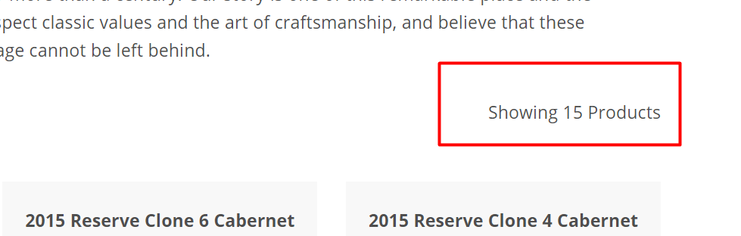

14:06 When you click on “Sort by” and select “Price high to low” it doesn’t show the wine list but shows the number of “Showing products”.

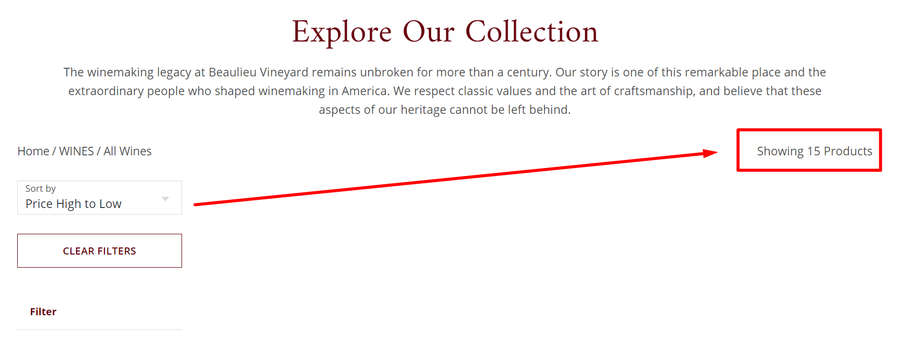

14:06 Click on “CLEAR FILTERS” – successfully loaded page.

14:07 Successfully sorted product by “Price High to Low”.

14:08 Click on “SHOP NOW” in the headers banner.

14:09 Set quantity for 2 bottles from the “Quick View” of every bottle.

14:10 Click on “ADD TO CART” and the operation was successful.

14:11 Add 650 bottles to the cart.

14:12 Error message shows up “Error: Sorry, not that many bottles available.”

14:13 Add 20 bottles and the operation was successful.

14:14 The Error message “Error: Sorry, not that many bottles available.” do not disappear. 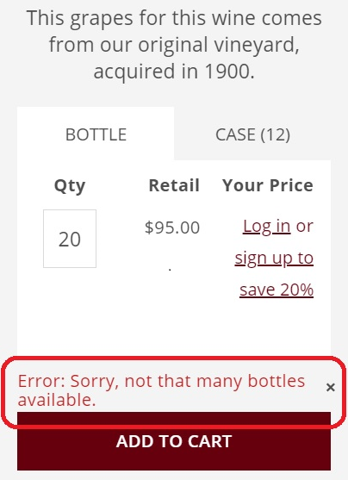

## 14:15 Add 500 bottles more.

## 14:16 Click on “ADD TO CART”. The button has changed to a big red button “SORRY”.

## 14:16 Click on “SORRY” button.

## 14:17 The system adds one more bottle to the cart.

## 14:18 Move mouse pointer to “Shopping cart icon”.

## 14:19 The hover effect shows that there are 21 bottles in the cart.

## 14:20 Click on “Minicard icon”.

## 14:21 Redirect to “checkoutlogin” page.

## 14:22 Remove all bottles from the cart's hover state. When it’s empty “The Cart” is unclickable.

## 14:22 Go to “View All Wines” Page.

## 14:23 Click on “DETAILS” from “Quick View” of every bottle.

## 14:24 Redirect to Product Details page.

## 14:25 Click on “Case” from the product type tab.

## 14:26 Set “Qty” to 10 and click on “ADD TO CART”.

## 14:27 10 cases have been successfully added to the cart.

## 14:28 Click on “ADD TO CART” to some bottle from “Customers Also Bought” section at the bottom.

## 14:29 One bottle has been successfully added to the cart (there is no option to choose more).

## 14:30 End of session.

## **Statistics from exploratory sessions**

|  |  |  |  |  |  |  |  |  |  |  |  |  |  |  |  |
| --- | --- | --- | --- | --- | --- | --- | --- | --- | --- | --- | --- | --- | --- | --- | --- |
| **The share of the found issues per session from the total of all found issues with the sessions**   |  |  |  | | --- | --- | --- | | **Exploratory sessions** | **Issues found** | **100.00%** | | Session 1 | 2 | 12.50% | | Session 2 | 4 | 25.00% | | Session 3 | 5 | 31.25% | | Session 4 | 5 | 31.25% |   Chart |
| **Issues found as a percent of the steps made by Session and from all of the sessions made.**   |  |  |  |  |  | | --- | --- | --- | --- | --- | | **Session** | **Steps made** | **Issues found** | **Percent of issues from the session's steps** | **Percent of issues from the total sessions steps** | | Session 1 | 10 | 2 | 20.00% | 2.86% | | Session 2 | 9 | 4 | 44.44% | 5.71% | | Session 3 | 19 | 5 | 26.32% | 7.14% | | Session 4 | 32 | 5 | 15.63% | 7.14% | | Total | **70** | **16** | **22.86%** |  | |

# Issues Found and Reported

List of the reported bugs ordered by severity

|  |  |  |
| --- | --- | --- |
| **Bug ID** | **Name** | **Severity** |
| 01 | By pressing Enter button sends the message in the contact form | 2 |
| 02 | Webpage elements get displaced | 3 |
| 03 | Missing Live Chat icon | 3 |
| 04 | Incorrect item number. | 3 |
| 05 | Password reset allows symbols that are not listed | 4 |
| 06 | Warning message for “City” input field on the shipping form is misleading | 4 |
| 07 | Warning message for “Zip Code” input field on the shipping form is misleading | 4 |
| 08 | No warning message for company name field | 4 |
| 09 | Dropdown arrow different from the rest | 4 |
| 10 | Different color of the hyperlinks in Account FAQ | 4 |
| 11 | The whole text is not written in one language | 4 |
| 12 | Broken hyperlinks in the footer menus | 4 |
| 13 | “Save and close” button in Cookie preferences page changes language | 4 |
| 14 | “Contact us” link at Shipping FAQ does not lead to correct “Contact us” page | 4 |
| 15 | Phone number inaccessible to dial directly at Virtual Wine Tasting section | 4 |
| 16 | Password reset does not recognize expected valid symbol (~) as valid but recognizes unexpected symbol (+) | 4 |
| 17 | Missing sanitization and validation for password strings when creating a new account | 4 |
| 18 | Missing sanitization and validation for password strings when editing an existing account | 4 |
| 19 | Error Message from Product Details | 4 |
| 20 | Incorrect position of option “Other” in dropdown menu | 5 |
| 21 | Price range formatted inconsistently | 5 |
| 22 | Irrelevant string “OR” at “Log In” page | 5 |
| 23 | Success and error messages are not shown on attempt for password change | 5 |
| 24 | Links in Privacy policy do not act like links | 5 |
| 25 | Redundant grey rectangle at Welcome page of new account creation | 5 |
| 26 | Backgrounds are overwrapping in “Sign Up & Save!” pop-up | 5 |

Severity 5 - Minor, 4 - Normal, 3 - Major, 2 - Blocker, 1 - Critical

|  |  |
| --- | --- |
| **Bug ID** | 01 |
| **Title** | By pressing Enter button sends the message in the contact form |
| **Severity** | 2 |
| **Description** | By pressing Enter button sends the message in the contact form |
| **Steps to reproduce** | 1. Open <https://www.bvwines.com/en/contact> 2. Click on “Contact Us” from footer menu 3. Enter valid information in required fields 4. Select “Subject” from the fall-down menu 5. Click to verify reCAPTCHA 6. Click on some field (First name, Last name, Email or Phone number) 7. Press the Enter button from the keyboard. |
| **Expected Result** | By pressing the Enter button from the keyboard you have to go to the next field or stay on the same field. |
| **Actual Result** | By pressing the Enter button from the keyboard the message is sent. |
| **Attachments** |  |
| **Component** | Contact Us |
| **Environment** | **Browser:** Chrome Version 91.0.4472.114 (Official Build) (64-bit)  **OS:** Windows 10HomeN build 19042.1052 |
| **Comment** | Please, note the bug is from Exploratory Session 1 |
| **Date Created** | 21.06.2021 |
| **Time Created** | 13:58 |
| **Author** | Georgi Angelov |

|  |  |
| --- | --- |
| **Bug ID** | 02 |
| **Title** | Webpage elements get displaced |
| **Severity** | 3 |
| **Description** | Opening the page <https://www.bvwines.com/en/trevor-durling-winemaker.html> and changing the zoom percentages on Chrome changes the position of some page elements. Rarely occurs. Refresh page to see differences if you spot any. This issue can be seen on most pages on the website. |
| **Steps to reproduce** | 1. Open webpage <https://www.bvwines.com/en/trevor-durling-winemaker.html>on Google Chrome 2. Change the zoom settings by holding ctrl and scrolling with the mouse wheel 3. Return to 100% zoom 4. Check page for misaligned elements. |
| **Expected Result** | Page elements to appear as they should when first loading the page |
| **Actual Result** | Page elements to appear differently than before |
| **Attachments** |  |
| **Component** | About |
| **Environment** | **Browser:** Chrome Version 91.0.4472.114 (Official Build) (64-bit)  **OS:** Windows 10HomeN build 19042.1052 |
| **Comment** | Reproducible on most pages on the website |
| **Date Created** | 24.06.2021 |
| **Time Created** | 22:07 |
| **Author** | Georgi Angelov |

|  |  |
| --- | --- |
| **Bug ID** | 03 |
| **Title** | Missing Live Chat icon |
| **Severity** | 3 |
| **Description** | Opening the contacts page appears a text saying “LIVE CHAT! Click on the icon in the bottom right of the screen to chat with a customer service agent during business hours.” However there is no icon that allows you to chat live with someone. |
| **Steps to reproduce** | 1. Open webpage <https://www.bvwines.com/en/contact> 2. Find the live chat section. |
| **Expected Result** | A live chat icon visible on page |
| **Actual Result** | No live chat icon visible |
| **Attachments** |  |
| **Component** | Contact us |
| **Environment** | **Browser:** Chrome Version 91.0.4472.114 (Official Build) (64-bit)  **OS:** Windows 10HomeN build 19042.1052 |
| **Comment** |  |
| **Date Created** | 26.06.2021 |
| **Time Created** | 15:30 |
| **Author** | Georgi Angelov |

|  |  |
| --- | --- |
| **Bug ID** | 04 |
| **Title** | Incorrect item number. |
| **Severity** | 3 |
| **Description** | Different number between amount of wines and Total shows wines on page. |
| **Steps to reproduce** | 1. Open https://www.bvwines.com/ 2. Go to “Wines” form the navigation bar in the header 3. Choose “Featured” 4. Select “90+ Points”. |
| **Expected Result** | The amount must be equal to the total number of filtered wines. |
| **Actual Result** | Different number between amount of wines by review score and Total shows wines on page |
| **Attachments** |  |
| **Component** | Only wines with 90+ points reviewer score |
| **Environment** | **Browser:** Chrome Version 91.0.4472.114 (Official Build) (64-bit)  **OS:** Windows 10HomeN build 19042.1052 |
| **Comment** | 2016 Beaulieu Vineyard Rarity Napa Valley Cabernet Sauvignon Magnum - There is no valuation |
| **Date Created** | 24.06.2021 |
| **Time Created** | 23:59 |
| **Author** | Georgi Angelov |

|  |  |
| --- | --- |
| **Bug ID** | 05 |
| **Title** | Warning message for “City” input field on the shipping form is misleading |
| **Severity** | 4 |
| **Description** | The error message should alert the user that the minimum length for “City” input field is 2 characters |
| **Steps to reproduce** | 1. Navigate to:https://www.bvwines.com/en/checkout?stage=shipping#shipping 2. The user enters invalid in “A” (only one character) into “City” input field |
| **Expected Result** | "Error: Must be between 2 to 50 characters required." мессаге should be displayed |
| **Actual Result** | “Error: Must be less than 50 character required” is displayed |
| **Attachments** |  |
| **Component** | Shipping form |
| **Environment** | **Browser:** Chrome Version 91.0.4472.114 (Official Build) (64-bit)  **OS:** Windows 10HomeN build 19042.1052 |
| **Comment** | The warning message should include the minimum length of characters required for this field |
| **Date Created** | 27.06.2021 |
| **Time Created** | 16:30 |
| **Author** | Georgi Angelov |

|  |  |
| --- | --- |
| **Bug ID** | 06 |
| **Title** | Warning message for “Zip Code” input field on the shipping form is misleading |
| **Severity** | 4 |
| **Description** | The error message should alert the user that the minimum length for “Zip Code ” input field is 5 characters instead of 4 |
| **Steps to reproduce** | 1. Navigate to:https://www.bvwines.com/en/checkout?stage=shipping#shipping 2. The user enters invalid data for zip code (only four characters) into “Zip Code” input field. |
| **Expected Result** | "Error: Must be between 5 to 10 characters required." message should be displayed |
| **Actual Result** | "Error: Must be between 4 to 10 characters required." message is displayed |
| **Attachments** |  |
| **Component** | Shipping form |
| **Environment** | **Browser:** Chrome Version 91.0.4472.114 (Official Build) (64-bit)  **OS:** Windows 10HomeN build 19042.1052 |
| **Comment** | The warning message should be adjusted to the code to display correct information |
| **Date Created** | 27.06.2021 |
| **Time Created** | 17:00 |
| **Author** | Georgi Angelov |

|  |  |
| --- | --- |
| **Bug ID** | 07 |
| **Title** | No warning message for company name field |
| **Severity** | 4 |
| **Description** | There is no warning message to show that the field length is 50 characters. |
| **Steps to reproduce** | 1. Navigate to:https://www.bvwines.com/en/checkout?stage=shipping#shipping 2. The user enters “sdgasdgasdgadsgasdgadsgasdg” into “Company Name” input field. |
| **Expected Result** | "Error: Must be less than 50 characters required.” |
| **Actual Result** | No warning message |
| **Attachments** |  |
| **Component** | Shipping form |
| **Environment** | **Browser:** Chrome Version 91.0.4472.114 (Official Build) (64-bit)  **OS:** Windows 10HomeN build 19042.1052 |
| **Comment** | The warning message should include the maximum length of characters required for this field |
| **Date Created** | 27.06.2021 |
| **Time Created** | 17:30 |
| **Author** | Georgi Angelov |

|  |  |
| --- | --- |
| **Bug ID** | 08 |
| **Title** | Redirect and select the wrong field |
| **Severity** | 4 |
| **Description** | When the user clicks on "checkout as guest" button he is redirected to “check out” page with the shipping form and the first selected field is “First Name” |
| **Steps to reproduce** | 1. Navigate to: https://www.bvwines.com/en/checkout?stage=shipping#shipping 2. The user's cursor is directed straight to the second input field(First Name) rather thаn first one(Email Address). |
| **Expected Result** | First selected field should be “Email Address” as it stands on top of the shipping form |
| **Actual Result** | Once the user is directed to the shipping form the first selected field is “First Name” |
| **Attachments** |  |
| **Component** | Shipping form |
| **Environment** | **Browser:** Chrome Version 91.0.4472.114 (Official Build) (64-bit)  **OS:** Windows 10HomeN build 19042.1052 |
| **Comment** | Once the shipping form is loaded the cursor should be placed in the first input field. |
| **Date Created** | 27.06.2021 |
| **Time Created** | 18:00 |
| **Author** | Georgi Angelov |

|  |  |
| --- | --- |
| **Bug ID** | 09 |
| **Title** | Dropdown arrow different from the rest |
| **Severity** | 4 |
| **Description** | One of the menus (Legal) has its dropdown arrow with a different icon. The issue can be reproduced on a Windows computer if you set a mobile screen resolution. This means that the issue should be reproducible on all mobile devices with similar screen resolutions and aspect ratios. |
| **Steps to reproduce** | 1. Open webpage <https://www.bvwines.com/> 2. Scroll to the bottom until you see the legal dropdown menu. |
| **Expected Result** | All dropdown menus have the same arrow icon |
| **Actual Result** | A single arrow icon is not like the rest |
| **Attachments** |  |
| **Component** | Footer |
| **Environment** | **Browser:** Chrome Version 91.0.4472.114  **OS:** Android 9 PKQ1.180904.001 |
| **Comment** |  |
| **Date Created** | 24.06.2021 |
| **Time Created** | 22:44 |
| **Author** | Georgi Angelov |

|  |  |
| --- | --- |
| **Bug ID** | 10 |
| **Title** | Different color of the hyperlinks in Account FAQ |
| **Severity** | 4 |
| **Description** | The color of the hyperlink “Sterling Vineyards” is different from the others. |
| **Steps to reproduce** | 1. Open <https://www.bvwines.com/>  2. Click to Account FAQ from the footer menu  3. Scroll down to “Common Questions & Answers”. |
| **Expected Result** | All of the hyperlinks have to be in one color. |
| **Actual Result** | The Sterling Vineyards hyperlink is blue. This is different from the others. It is possible for the user to be misled about a different result when clicking on the link compared to the others. |
| **Attachments** |  |
| **Component** | Account FAQ |
| **Environment** | **Browser:** Chrome Version 91.0.4472.114 (Official Build) (64-bit)  **OS:** Windows 10HomeN build 19042.1052 |
| **Comment** | - |
| **Date Created** | 22.06.2021 |
| **Time Created** | 11:46 |
| **Author** | Georgi Angelov |

|  |  |
| --- | --- |
| **Bug ID** | 11 |
| **Title** | The whole text is not written in one and the same language |
| **Severity** | 4 |
| **Description** | When you change the language from English to Chinese part of the text remains still in English. |
| **Steps to reproduce** | 1. Open the webpage<https://www.bvwines.com/> 2. Change the language from English to Chinese from the upper right corner. |
| **Expected Result** | A page written only in Chinese |
| **Actual Result** | A page with text in two different languages |
| **Attachments** |  |
| **Component** | Language option - Chinese translation |
| **Environment** | **Browser:** Chrome Version 91.0.4472.114 (Official Build) (64-bit)  **OS:** Windows 10HomeN build 19042.1052 |
| **Comment** | - |
| **Date Created** | 24.06.2021 |
| **Time Created** | 23:59 |
| **Author** | Georgi Angelov |

|  |  |
| --- | --- |
| **Bug ID** | 12 |
| **Title** | Broken hyperlinks in footer menu |
| **Severity** | 4 |
| **Description** | The hyperlinks in the footer menu are not active. |
| **Steps to reproduce** | 1. Open<https://www.bvwines.com/> 2. Scroll down to the footer menu 3. Click on Service, Legal, Information, Other or BEAULIEU VINEYARD © 2021. |
| **Expected Result** | The cursor shows us that these options are hyperlinks. If we click on them we have to be redirected to the relevant page. |
| **Actual Result** | There is no action when we click on pointed hyperlinks. |
| **Attachments** |  |
| **Component** | Footer menu |
| **Environment** | **Browser:** Chrome Version 91.0.4472.114 (Official Build) (64-bit)  **OS:** Windows 10HomeN build 19042.1052 |
| **Comment** | - |
| **Date Created** | 25.06.2021 |
| **Time Created** | 15:40 |
| **Author** | Georgi Angelov |

|  |  |
| --- | --- |
| **Bug ID** | 13 |
| **Title** | “Save and close” button in Cookie preferences page changes language |
| **Severity** | 4 |
| **Description** | Opening the Cookie preferences page, changing the language and clicking on “Save and close” button will change the language again. Every Click will switch the language. Starting on either language will trigger the issue. |
| **Steps to reproduce** | 1. Open webpage <https://www.bvwines.com/en/tealium-cookie/consent-preference.html> 2. Change the language 3. Click on “Save and close” button 4. The language will be changed 5. Click on “Save and close ” button again 6. The language will be changed again |
| **Expected Result** | Saving preferences for cookie buttons when “Save and close” button is clicked |
| **Actual Result** | Changing language when “Save and close” button is clicked |
| **Attachments** |  |
| **Component** | Cookies |
| **Environment** | **Browser:** Chrome Version 91.0.4472.114  **OS:** Android 9 PKQ1.180904.001 |
| **Comment** |  |
| **Date Created** | 28.06.2021 |
| **Time Created** | 12:32 |
| **Author** | Georgi Angelov |

|  |  |
| --- | --- |
| **Bug ID** | 14 |
| **Title** | “Contact us” link at Shipping FAQ does not lead to correct “Contact us” page |
| **Severity** | 4 |
| **Description** | On the “Shipping FAQ” page, section “More Questions” there is a link to the contact details which does not direct the user to the correct contact page. |
| **Steps to reproduce** | 1. Open webpage <https://www.bvwines.com/> 2. Scroll down to the bottom of the home page 3. Click on “Shipping FAQ” from the “Service” footer menu 4. Scroll to the end of the FAQs 5. Click on “Contact us” in the “More Questions” section. |
| **Expected Result** | Redirecting to Contact Us page displaying contact form or contact channels |
| **Actual Result** | Display of page saying “**Your search for " " found no results**.” |
| **Attachments** |  |
| **Component** | Shipping FAQ |
| **Environment** | **Browser:** Google Chrome, Version 91.0.4472.114 (Official Build) (64-bit)  Microsoft Edge, Version 91.0.864.54 (Official build) (64-bit)  **OS:** Windows 10 Pro 19043.1052 |
| **Comment** | n/a |
| **Date Created** | 26.06.2021 |
| **Time Created** | 16:46 |
| **Author** | Georgi Angelov |

|  |  |
| --- | --- |
| **Bug ID** | 15 |
| **Title** | Phone number inaccessible to dial directly at Virtual Wine Tasting section |
| **Severity** | 4 |
| **Description** | Contact phone number is provided as a hyperlink for direct dial. The number includes semicolon at the end, which prevents the direct dial from a phone |
| **Steps to reproduce** | 1. Open webpage <https://www.bvwines.com/> 2. Click on the hamburger icon in the top left corner. 3. From “Virtual” drop down menu select item “Virtual Wine tasting” 4. Click on “Get started” button at the top banner “Virtual Wine experiences by Beaulieu Vineyard”. 5. A page is displayed with inquiry fields to be filled or direct call to be made. 6. Click on the hyper linked phone number in the body of the text. |
| **Expected Result** | The phone number appears directly in the dial pad of the phone and a call can be made right away |
| **Actual Result** | The phone number appears in the dial pad with semicolon at the end - a call can not be made |
| **Attachments** |  |
| **Component** | Virtual Wine Tasting |
| **Environment** | **Browser:** Google Chrome, Version 91.0.4472.101  **OS:** Android 11; SM-A415F Build/RP1A.200720.012 |
| **Comment** | Observation and Recommendation: Phone numbers on the website do not bear the international US dial code, which makes it impossible to dial directly from outside of the US. The user dialing from abroad needs to type the US code manually. |
| **Date Created** | 26.06.2021 |
| **Time Created** | 17:31 |
| **Author** | Georgi Angelov |

|  |  |
| --- | --- |
| **Bug ID** | 16 |
| **Title** | Password reset does not recognize expected valid symbol (~) as valid but recognizes unexpected symbol (+) |
| **Severity** | 4 |
| **Description** | The password reset option does not recognize the expected symbol ~ as valid  Condition - At least 1 symbol (~!@#$%^&) - fail (~ is not allowed. Attachment 1)  Before the reset the password contained invalid symbols. It was created like: Pass123~!@#$%^& *()_+\/.,';| |
| **Steps to reproduce** | 1. With an existing user request a password reset link via the option “Forgot password?” from <https://www.bvwines.com/en/login?stage=email#email> 2. Check the email and follow the link 3. Enter “Pass123~” 4. Try to click on button “Reset password” 5. Enter “Pass123+” 6. Try to click on button “Reset password” |
| **Expected Result** | * The password is accepted and the button can be clicked with Pass123~ * The password is not accepted, error message and the button “RESET PASSWORD” can not be clicked with Pass123+ |
| **Actual Result** | * Error message “Error: Please check that you meet our password security requirements and try again.” is displayed and the button can not be clicked with password Pass123~ * The password is successfully changed to Pass123+ |
| **Attachments** | Attachment 1 - ~ is not accepted as valid symbol    Attachment 2 - + is accepted as valid symbol |
| **Component** | Log in, Account - forgot password |
| **Environment** | **Browser:** Chrome Version 91.0.4472.114 (Official Build) (64-bit)  **OS:** Windows 10HomeN build 19042.1052 |
| **Comment** | After successfully changing the password to Pass123+ the user can log in without problems.  Discovered while performing different password tests. Related bugs ??? |
| **Date Created** | 27.06.2021 |
| **Time Created** | 23:47 |
| **Author** | Georgi Angelov |

|  |  |
| --- | --- |
| **Bug ID** | 17 |
| **Title** | Missing sanitization and validation for password strings when creating a new account |
| **Severity** | 4 |
| **Description** | The password string unexpectedly recognizes white space ““, apostrophe “**'**“ and other unspecified in the password tooltip symbols as valid user credentials. The event occurs when the user creates an account.  Strong password requirements:  Minimum 8 characters  At least 1 upper case letter - pass  At least 1 lower case letter - pass  At least 1 symbol (~!@#$%^&) - fail (the field receives a wide variety of symbols)  At least 1 number - pass |
| **Steps to reproduce** | 1. Go to Log in ( <https://www.bvwines.com/en/login?stage=email#email> ) 2. Click on “Create account” and enter valid account data 3. Enter “Pass123~!@#$%^& *()_+\/.,';|” for password 4. Check for an error message forbidding the input 5. Click on the button “Create account” 6. After the successful log in, log off from the account 7. Try to enter with the expected user credentials |
| **Expected Result** | * Error message * Can not create an account until a valid password with the specified criteria is entered * Must repeat password for doublecheck * Successfully log in with the accepted password |
| **Actual Result** | * No error message * The password accepts a wide variety of special characters beyond the scope of the allowed ones * There is no field to enter the password again * The account is created * After the first log off can no longer log in again with the accepted password user password. |
| **Attachments** | Attachment 1 - Pass123~!@#$%^& *()_+\/.,';| - no error message.    Attachment 2 - Account created. (Ignore the error message on top - it stayed after an attempt to create an account for an existing email) |
| **Component** | Log in, Create account |
| **Environment** | **Browser:** Chrome Version 91.0.4472.114 (Official Build) (64-bit)  **OS:** Windows 10HomeN build 19042.1052 |
| **Comment** | If the user comes from an email with a valid token for password reset, the fields are secured and they work.A descriptive error message is shown and nothing happens when the button is pressed in case of unexpected data.  **A hint** might be that the fields in password reset do not give the user the opportunity to see his password, instead he sees the masked version with *. These 2 types of password fields might be handled differently in the code.  See Bud ID 16 for more info about the behaviour of password reset.  Related to Bug ID 18  **Warning:** The gif is attached via public URL due to breaking up when attached locally or from google docs. Problems are possible  **Disclaimer:** there was no attempt to harm the website. This test was conducted as a string manipulation and not as a security check. The attempts included positive and negative checks of the password requirements. |
| **Date Created** | 28.06.2021 |
| **Time Created** | 02:00 |
| **Author** | Georgi Angelov |

|  |  |
| --- | --- |
| **Bug ID** | 18 |
| **Title** | Missing sanitization and validation for password strings when editing an existing account |
| **Severity** | 4 |
| **Description** | The password string unexpectedly recognizes white space ““, apostrophe “**'**“ and other unspecified in the password tooltip symbols as valid user credentials. The event occurs when the user edits his account.  Strong password requirements:  Minimum 8 characters  At least 1 upper case letter - pass  At least 1 lower case letter - pass  At least 1 symbol (~!@#$%^&) - fail (the field receives a wide variety of symbols)  At least 1 number - pass |
| **Steps to reproduce** | 1. Go to Log in ( <https://www.bvwines.com/en/login?stage=email#email> ) 2. Log in with an existing account 3. Go to account settings 4. Click on the button “Change password” 5. Enter the valid password 6. Enter password “ Pass ‘123! ” 7. Repeat the new password 8. Click on “Save” 9. Log out 10. Try to log in with the new password 11. Try to log in with the old password |
| **Expected Result** | * An error message for the new password. * An error message for the repeated password * Do not save passwords with special characters beyond or below the overall scope * Successfully log in with the accepted password or old password |
| **Actual Result** | * No error messages are displayed when changing the password * The password accepts a wide variety of special characters beyond the scope of the allowed ones * Cannot log in with the accepted password after log off * Cannot log in with the old password. |
| **Attachments** | Attachment 1 - edit profile - change password |
| **Component** | Log in, Edit profile - change password |
| **Environment** | **Browser:** Chrome Version 91.0.4472.114 (Official Build) (64-bit)  **OS:** Windows 10HomeN build 19042.1052 |
| **Comment** | Related to Bug ID 17  **Warning:** The gif is attached via public URL due to breaking up when attached locally or from google docs. Problems are possible |
| **Date Created** | 28.06.2021 |
| **Time Created** | 02:25 |
| **Author** | Georgi Angelov |

|  |  |
| --- | --- |
| **Bug ID** | 19 |
| **Title** | Error Message from Product Details |
| **Severity** | 4 |
| **Description** | After successful operation the error message does not disappear. |
| **Steps to reproduce** | 1. Open <https://www.bvwines.com/> 2. 2.Click “SHOP NOW” from the header’s banner 3. 3.Set quantity (Qty) to 650 from the quick view and click “ADD TO CART” button 4. 4.Set quantity (Qty) to 20 from the quick view and click “ADD TO CART” button. |
| **Expected Result** | The error message “Error: Sorry, not that many bottles available.” do not disapear. |
| **Actual Result** | The message does not disappear but we can close it |
| **Attachments** |  |
| **Component** | Product Detail |
| **Environment** | **Browser:** Chrome Version 91.0.4472.114 (Official Build) (64-bit)  **OS:** Windows 10HomeN build 19042.1052 |
| **Comment** | The error message should disappear after successful operation. |
| **Date Created** | 24.06.2021 |
| **Time Created** | 10:20 |
| **Author** | Georgi Angelov |

|  |  |
| --- | --- |
| **Bug ID** | 20 |
| **Title** | Incorrect position of option “Other” in dropdown menu |
| **Severity** | 5 |
| **Description** | The “Other” option in the subject menu is not located at the end of the list. Instead, it is found somewhere in the middle. |
| **Steps to reproduce** | 1.Open webpage <https://www.bvwines.com/en/contact>  Click on the subject dropdown to select your option. |
| **Expected Result** | Option “Other” is in the bottom of the list |
| **Actual Result** | Option “Other” is somewhere in the middle of the list |
| **Attachments** |  |
| **Component** | Contact us |
| **Environment** | **Browser:** Chrome Version 91.0.4472.114 (Official Build) (64-bit)  **OS:** Windows 10HomeN build 19042.1052 |
| **Comment** | The dropdown menu doesn’t have a logical order (alphabetical, most common, etc...) |
| **Date Created** | 24.06.2021 |
| **Time Created** | 16:11 |
| **Author** | Georgi Angelov |

|  |  |
| --- | --- |
| **Bug ID** | 21 |
| **Title** | Price range formatted inconsistently |
| **Severity** | 5 |
| **Description** | The price range filter uses min and max numerical value in different precision format. |
| **Steps to reproduce** | 1. Open webpage <https://www.bvwines.com/> 2. Hover over “Wine” in the top right area. 3. Click on “All Wines” 4. Click on “Price Range” - the bottom filter on the right. |
| **Expected Result** | The product price in the filter displayed as integer |
| **Actual Result** | The min price is integer, the max price is float. When using the sliding handle, the price format toggles between integer and float |
| **Attachments** |  |
| **Component** | Filter “Price range” |
| **Environment** | **Browser:** Google Chrome, Version 91.0.4472.114 (Official Build) (64-bit),  Microsoft Edge, Version 91.0.864.54 (Official build) (64-bit)  **OS:** Windows 10HomeN build 19042.1052 |
| **Comment** |  |
| **Date Created** | 24.06.2021 |
| **Time Created** | 21:37 |
| **Author** | Georgi Angelov |

|  |  |
| --- | --- |
| **Bug ID** | 22 |
| **Title** | Irrelevant string “OR” at “Log In” page |
| **Severity** | 5 |
| **Description** | String “OR” in the middle of the log in area not leading to options. |
| **Steps to reproduce** | 1. Open webpage <https://www.bvwines.com/> 2. Click on “Log In” menu in the top right corner of the home page. |
| **Expected Result** | Display of Log In area with required fields for login and “Create Account” button |
| **Actual Result** | Display of string “OR” in the “Log In” area, where no options are available |
| **Attachments** |  |
| **Component** | Log In |
| **Environment** | **Browser:** Google Chrome, Version 91.0.4472.114 (Official Build) (64-bit),  Microsoft Edge, Version 91.0.864.54 (Official build) (64-bit)  **OS:** Windows 10HomeN build 19042.1052 |
| **Comment** | Found in Exploratory session 3 |
| **Date Created** | 24.06.2021 |
| **Time Created** | 22:44 |
| **Author** | Georgi Angelov |

|  |  |
| --- | --- |
| **Bug ID** | 23 |
| **Title** | Success and error messages are not shown on attempt for password change |
| **Severity** | 5 |
| **Description** | The user does not receive proper messages for success or error when the new password is being processed in his account settings |
| **Steps to reproduce** | 1. Log in with an existing account 2. Go to profile settings <https://www.bvwines.com/en/profile> 3. Click on “Change password” and enter the current password 4. As a new password, enter the invalid “ “ (8 white spaces) and save 5. Notice if there are any messages 6. Exit the system 7. Try logging in with the account and “ “ (8 white spaces) 8. Try logging in with the last known password 9. Repeat steps 1-3 10. As a new password, enter a valid string (e.g. “Pass123!”) and save. 11. Notice if there are any messages 12. Exit the system 13. Try logging in with the last known password before the one from step 10 14. Try logging in with the password used in step 10 (e.g. “Pass123!”) |
| **Expected Result** | * The user receives error message on step 4 * The user receives a success message on step 10 |
| **Actual Result** | The user does not receive proper information about the status of the password change request. |
| **Attachments** | Attachment - The user tries to set up passwords and expects messages  It shows the lack of messages which may lead to confusion |
| **Component** | Log in, Change password |
| **Environment** | **Browser:** Chrome v. 91.0.4472.114 with ABP adblock - v. 3.11  **OS:** Windows 10HomeN build 19042.1052 |
| **Comment** | The gif is attached via public URL due to breaking up when attached locally or from google docs. Problems are possible |
| **Date Created** | 28.06.2021 |
| **Time Created** | 01:04 |
| **Author** | Georgi Angelov |

|  |  |
| --- | --- |
| **Bug ID** | 24 |
| **Title** | Links in Privacy policy do not act like links |
| **Severity** | 5 |
| **Description** | By entering the privacy policy the user sees the following line “Please use any of these quick links below to navigate to the appropriate section of the privacy policy.” followed by a list of topics. When the user tries to navigate quickly to any of the topics nothing happens. The cursor does not change to “pointer”. |
| **Steps to reproduce** | 1. Go to privacy policy <https://www.bvwines.com/en/privacy-policy.html> 2. Notice a change in the cursor from “default” to “pointer” 3. Try to click on the bolded rows before the line (e.g. try clicking on “Security”) |
| **Expected Result** | * The cursor changed to “pointer” * The links lead to the correct place in the document |
| **Actual Result** | The cursor does not change and the topics are not linked, so they do not lead to the correct place in the page. |
| **Attachments** | Attachment - The user tries to set up passwords and expecting messages |
| **Component** | Privacy policy |
| **Environment** | **Browser:** Chrome v. 91.0.4472.114 with ABP adblock - v. 3.11  **OS:** Windows 10HomeN build 19042.1052 |
| **Comment** |  |
| **Date Created** | 28.06.2021 |
| **Time Created** | 00:35 |
| **Author** | Georgi Angelov |

|  |  |
| --- | --- |
| **Bug ID** | 25 |
| **Title** | Redundant grey rectangle at Welcome page of new account creation |
| **Severity** | 5 |
| **Description** | A grey rectangle with no purpose appears upon creation of new account |
| **Steps to reproduce** | 1. Open webpage <https://www.bvwines.com/> 2. Click on “Log In” in the top right corner. 3. Click on “Create Account” 4. Follow the required fields (first name, last name, date of birth, email address, password) 5. Click on “Create Account”. |
| **Expected Result** | Redirecting to Account page displaying account information and other user specific information |
| **Actual Result** | Welcome page is displayed with grey rectangle in the middle with no specific purpose |
| **Attachments** |  |
| **Component** | Create Account |
| **Environment** | **Browser:** Google Chrome, Version 91.0.4472.114 (Official Build) (64-bit)  Microsoft Edge, Version 91.0.864.54 (Official build) (64-bit)  **OS:** Windows 10HomeN build 19042.1052 |
| **Comment** | Found in Exploratory session 3 |
| **Date Created** | 26.06.2021 |
| **Time Created** | 15:39 |
| **Author** | Georgi Angelov |

|  |  |
| --- | --- |
| **Bug ID** | 26 |
| **Title** | Backgrounds are overwrapping in “Sign Up & Save!” pop-up |
| **Severity** | 5 |
| **Description** | The red background on hover over X for closing the pop-up and the grey background on the discount message overwrap on hover over X. |
| **Steps to reproduce** | 1. Log in to the website on a browser without saved cookies or in incognito mode 2. Wait for the pop-up window to join the mailing list 3. Hover over X to close it |
| **Expected Result** | Each element has its own space and they do not overwrap |
| **Actual Result** | The red background stay below the grey background |
| **Attachments** |  |
| **Component** | Mailing list pop-up |
| **Environment** | **Browser:** Chrome v. 91.0.4472.114 with ABP adblock - v. 3.11  It repeats on Edge and Firefox  **OS:** Windows 10HomeN build 19042.1052 |
| **Comment** |  |
| **Date Created** | 28.06.2021 |
| **Time Created** | 02:45 |
| **Author** | Georgi Angelov |